**Power BI Assignment 2**

1. **Explain the advantages of Natural Queries in PowerBi with an example?**

* It does not require a prior knowledge of any querying language like SQL etc. The querying can be done using usual/common and natural English language.
* It helps to reduce confusion to layman.
* Power Bi helps to complete the query as we see in VS code or other code editor as user enter/type the query which helps the user to query faster and easily
* Once the dashboard/report is submitted by analyst to the business stakeholders, they can easily query on their own in the report

Example: If we want query Show total sales in the last year. The Power Bi understand this query and as we type show it suggest all feature available to complete the query.

1. **Explain Web Front End (WFE) cluster from Power BI Service Architecture?**

As we know the report or dashboard created can be published online on a cloud platform known as Power Bi Services. The other users can access these reports and dashboard from Power Bi services using various platform like websites, desktops, mobile. This means a user can access the report/dashboard published on cloud platform must interact with Power Bi services.

Power Bi Services consist of two clusters:

1. Web Front End Cluster

2. Back End Cluster

The Web Front End Cluster acts as an intermediary between user and the back end. The two important tasks of front-end cluster are establishing an initial connection and authenticating user using Azure Directory. The User Directory stores user identities. Along with this, Azure Traffic Manager is used to direct user requests to the nearest data center after authentication. As user is authenticated the Azure Content Delivery Network (CDN) distribute static Power Bi content/files to users.

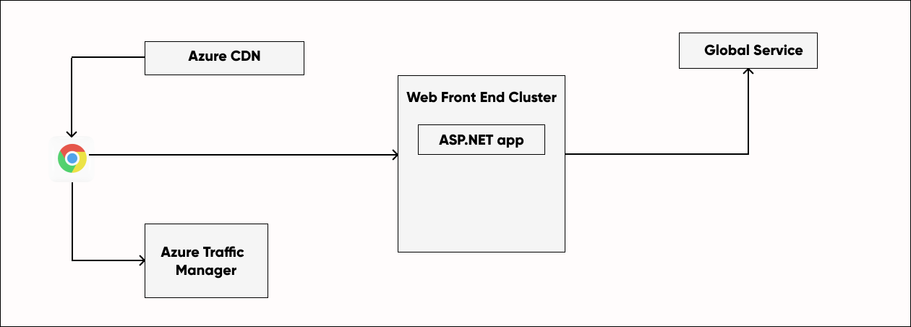

1. **Explain Back End cluster from Power BI Service Architecture?**

The Power Bi service at the back end take care of following things

* Visualization
* Reports
* Storage
* Datasets
* Data Connection
* Data refreshing and interaction with Power Bi

At the back-end a web client has only two direct point od interaction Azure API Management and Gateway Role. These two components are responsible for load balancing. Authentication, authorization, routing etc

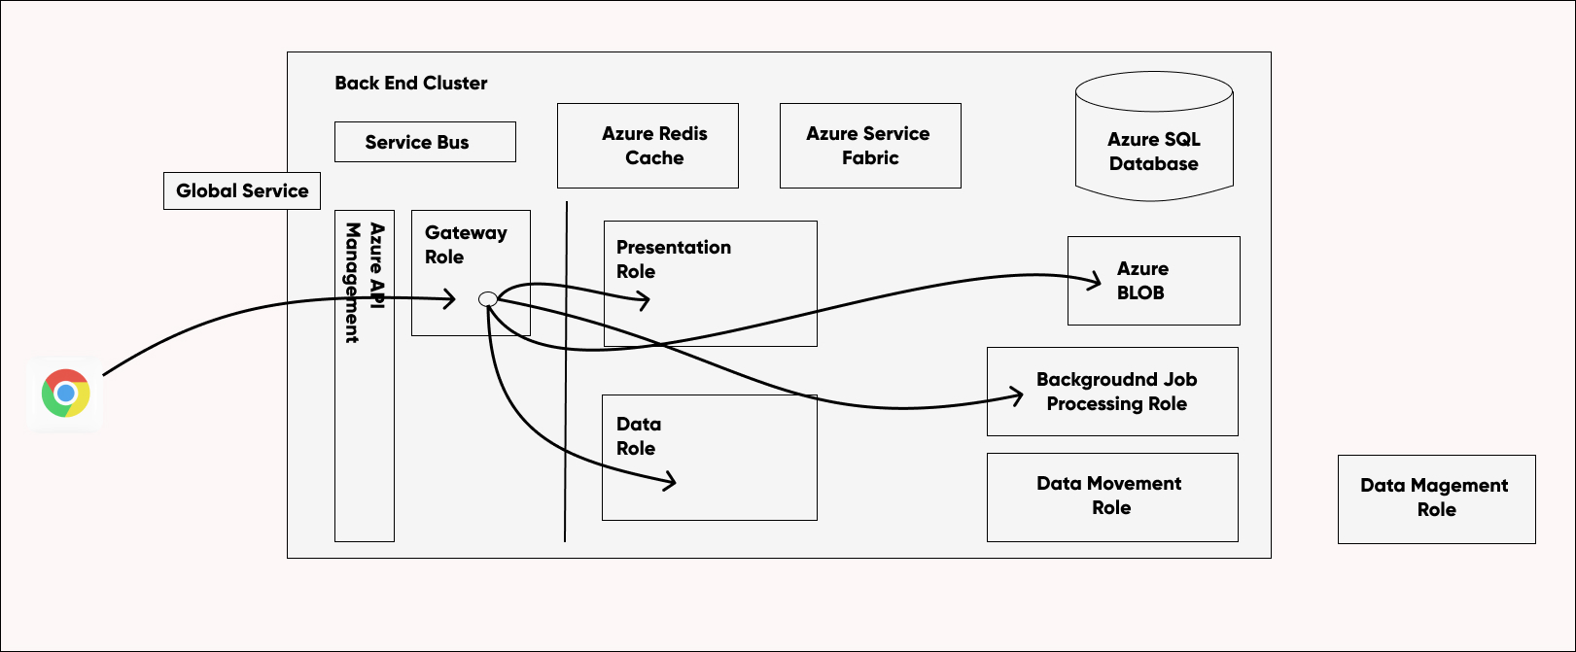

1. **What ASP.NET component does in Power BI Service Architecture?**

ASP.NET is web development platform provided by Microsoft

* ASP = Active Server Page
* NET = Network Enabled Technologies

ASP.NET plays an important role in publishing the report and dashboards online on workspace where other user can interact with it in front end provided by Power Bi Service. Not only that BI dashboard can be accessed by user using other Microsoft applications such as Teams which embeds BI Application through ASP.NET framework.

1. **Compare Microsoft Excel and PowerBi Desktop on the following features: Data import Data transformation Modeling Reporting Server Deployment Convert Models Cost**

|  |  |  |
| --- | --- | --- |
| Aspects | Microsoft Excel | Microsoft Power Bi |
| Data Import | The data in excel can be imported from limited data sources. | The data in Power BI can be imported from around 100 data sources which more than excel |
| Data Transformation | Data transformation is easy in excel using power query editor. | Data transformation can be done in Power Bi using power Query Editor which as some additional feature as compare to excel. |
| Modelling | Excel is totally focused of structured and simple data models with wide range of features. | Power Bi is really focused on data ingest and building potentially complex data mode easily. |
| Reporting | Excel reports are normal and ordinary as excel has fewer visualizing techniques as compare to Power Bi | The Power Bi reports are beautiful, branded as compare to Excel and it have more visualizing technique in comparison to Excel |
| Server Deployment | Can share report in excel by saving it to a Document Management Server. | Can share publish the report in Power Bi Service which can be further accessed by another user in workspace |
| Convert Models | Complex Model can be converted and used Excel | Models used in Excel File can be converted and used in Power Bi |
| Cost | Excel in include in Microsoft 365 Business Standard Package that costs around $9 per user per month | Power Bi cost depends on how many projects you need and the amount of power you will use to crunch and display your data. There are basically four subscriptions available. |

1. **List 20 data sources supported by Power Bi desktop.**

In Power Bi we can import data from following data sources:

* Excel Workbook
* Text/CSV
* XML
* JSON
* Folder
* PDF
* SharePoint Folder
* Parquet
* SQL Server Database
* Oracle Database
* PostgreSQL Database
* Teradata Database
* Vertica
* Impala
* Azure SQL Database
* Salesforce Objects
* Google Analytics
* GitHub (Beta)
* Smartsheet
* Spark
* Amazon Athena
* Azure Databricks
* Vena
* Viva Insights